**CN lab task09**

# 

***(Computer Networking Lab )***

**Muhammad Babar ALI**

*( SU92-BSSEM-F22-065 )*

BSSE – 5B ( 2022 – 2026)

**Department Of Software Engineering**

Submitted to: Sir Rasikh ali

Submitted on: Dec 10,2024

**Faculty Of CS&IT ( Gold Campus ), Superior University, Lahore**

### **Subnetting**

* **Definition:** Subnetting involves dividing a larger network (IP block) into smaller subnetworks (subnets). It allows efficient utilization of IP addresses and provides better control over network traffic.
* **Purpose:** Used to isolate traffic, improve security, and efficiently allocate IP addresses.

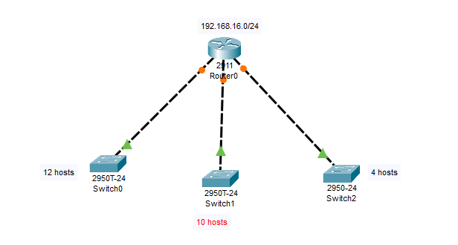

### **Supernetting**

* **Definition:** Supernetting involves combining multiple smaller networks (IP blocks) into a larger one. This process is often called route aggregation.
* **Purpose:** Reduces the size of routing tables and simplifies routing in larger networks.

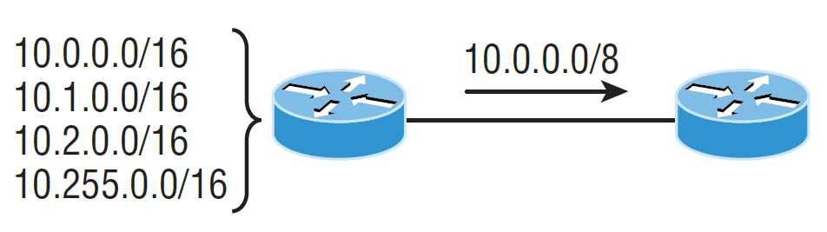

### **Comparison**

|  |  |  |
| --- | --- | --- |
| **Feature** | **Subnetting** | **Supernetting** |
| **Purpose** | Divide a network | Combine networks |
| **Efficient Usage** | Saves IPs in LANs | Reduces routing overhead |
| **Bit Adjustment** | Borrow host bits for subnets | Borrow network bits for supernet |